CS1102-Assignment I

- Write a program that will print your initials to standard output in letters that are nine (solution) lines tall. Each big letter should be made up of a bunch of *’s. For example, if your initials were “DJE”, then the output would look something like:
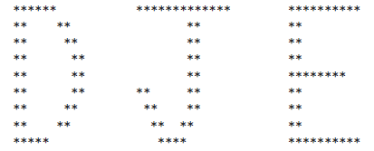
- Write a program that plays a word game with the user. The program should ask the user to enter the following:
His or her name, His or her age, The name of a city, The name of a college, A profession, A type of animal, A pet’s name
After the user has entered these items, the program should display the following story, inserting the user’s input into the appropriate locations:
There once was a person named NAME who lived in CITY. At the age of AGE, NAME went to college at COLLEGE. NAME graduated and went to work as a PROFESSION. Then, NAME adopted a(n) ANIMAL named PETNAME. They both lived happily ever after!
- A bus company organizes a tour. each participant would pay $2500. Given the number of participants, write a program that calculate and prints the revenue the company will generate for the tour.
- Write a program that reads number of gallons of gas in the tank of a car, the number of miles per gallon, and the price of gas per gallon. the program then computes and prints:
1 - How far (in miles) the car can travel with the gas
2 - The cost of travelling 250 miles with the car
- If you have N eggs, then you have N/12 dozen eggs, with N%12 eggs left over. (This is (solution) essentially the definition of the / and % operators for integers.) Write a program that asks the user how many eggs she has and then tells the user how many dozen eggs she has and how many extra eggs are left over.
A gross of eggs is equal to 144 eggs. Extend your program so that it will tell the user
how many gross, how many dozen, and how many left over eggs she has. For example, if
the user says that she has 1342 eggs, then your program would respond with
Your number of eggs is 9 gross, 3 dozen, and 10

- Write a program that reads the performance level of an employee (between 0 and 100) and his salary. Then it increases the salary by 3% if performance level is greater than or equal to 90.
Here are two sample runs:
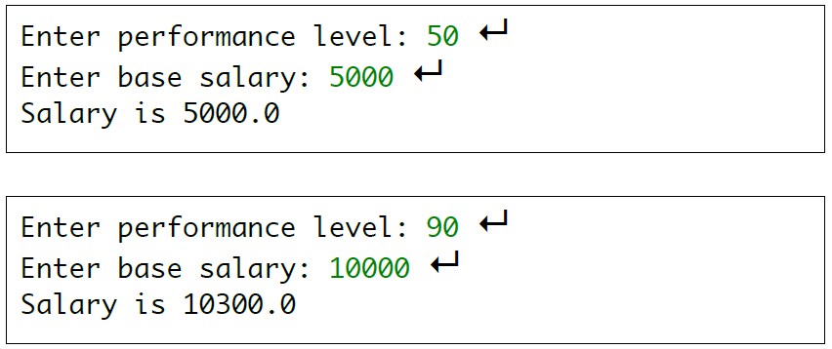
- Write a program to take two numbers as input then display both HCF and LCM of those two numbers.
- Write a program that prompts the user to enter the minutes (e.g., 1 billion), and displays the number of years and days for the minutes. For simplicity, assume a year has 365 days.
Use class name MinsToYearsDays
Here is a sample run:
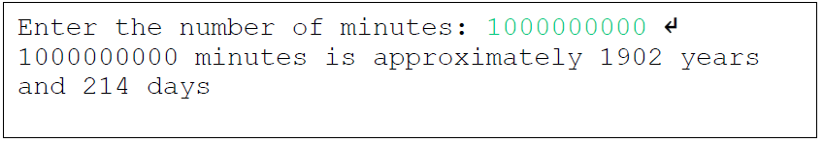
- Write a program to find the average of the students grades knowing that the number of the students and the student score shall be given by the user.
Notes: The Number of students should be more than zero, and the student score should be between 0 - 100
Assign letter grades for the student average based on the distribution below:
A : 90 – 100
B : 80 – 89
C : 70 – 79
D : 60 – 69
F : 0 – 59
Count and print the number of the students who got an A.
- Write a program that prompts the user to enter a three-digit integer and determines whether it is a palindrome number. A number is palindrome if it reads the same from right to left and from left to right. Here are two sample runs:
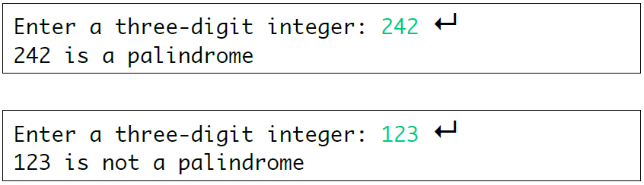
- Write an application that inputs one number consisting of five digits from the user, separates the number into its individual digits and prints the digits separated from one another by three spaces each. For example, if the use types in the number 42339, the program should print 4 2 3 3 9
… Assume that the user enters the correct number of digits. What happens when you execute the program and type a number with more than five digits? What happens when you execute the program and type a number with fewer than five digits? [ Hint: it’s possible to do this exercise with the techniques you learned till now. You’ll need to use both division and remainder operations to “pick off” each digit.]
- write a program to accept a number from user and print the following: -
1.sum of the digits
2.number of digits
3.reverse of the digits
4.largest digit
- Write a program that uses for statements to print the following patterns separately, one below the other. Use for loops to generate the patterns. All asterisks (*) should be printed by a single statement of the form print (“*”).
*  **  ***  ****  *****  ****** | ******  *****  ****  ***  **  * | ******  *****  ****  ***  **  * | *  **  ***  ****  *****  ******

