Multiple Choice
- Stack
- Given two sorted stacks stack1 and stack2, implement a function mergeStacks that merges the content of stack1 and stack2 in a new stack result_stack in such a way that the result stack is also sorted (either descendinly or ascendingly). [3 marks]
- Given two stacks stack1 and stack2, write a function isSimilar that checks whether the two stack are exactly similar and returns true if it is the case; otherwise, it return false. [3 marks]
- Write a stack implementation using linked lists. [4 marks]
- Use the infix to postfix algorithm to transform the following expressions into its postifx form. Show the content of the stack and postfix list each time you scan a new token from the expression: [2 marks]
  - A+B*C-D/E*F
  - (A+B*C-D)/ (E*F)
- Queue
- Given a Queue Q, write a method that will find the max element in the queue. You may only use queue operations such as eneque, dequeue, size etc.. No other data structure can be used other than queues. Queue must remain intact after finding the max. The elements in the queue can be compared using compareTo method [4 marks]
- Write a C program to implement linear queue using array with following operations [8 marks]
    - Enqueue
    - Dequeue
    - Count number of items
    - Display (tail to head)
- List
- Write a method in the LinkedList class. The method contains is supposed to return true if the there is a node in the list that is equal to the given Comparable c. You can assume the Node class has the public fields, data (a Comparable) and next (a pointer to another Node) [3 marks]
- Assume a linked list that holds integers. Suppose that you want to count how many positive values are on the list. Write a function countPositive that returns the count of values. [3 marks]
- Assume a linked list that holds at least 2 integers. Suppose that you want to insert a new node in the end of the list ONLY if its value is greater than the value of the last node of the list. Write a function insertWithCondition that performs the insertions. [3 marks]
- Write a function encryptList that traverse a linked list and prints double the data value of the nodes [3 marks]
- Tree
  - 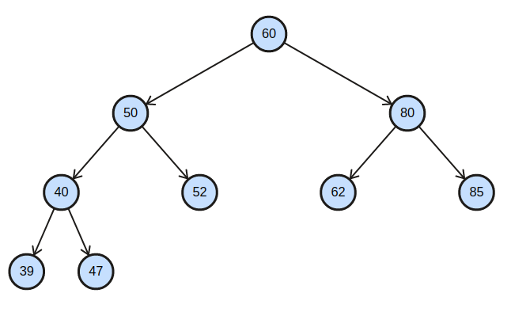
    - What is the sequence of visited nodes if the tree is traversed using inorder traversal [2 marks]
    - What is the sequence of visited nodes if the tree is traversed using postorder traversal [2 marks]
    - What is the sequence of visited nodes if the tree is traversed using preorder traversal [2 marks]
    - Is the tree complete? Justify [1 mark]
    - Is the tree full? If not, add more nodes to it to make it full. [1 mark]
  - Create a binary search tree using the following data elements: [2 marks]
45, 39, 56, 12, 34, 78, 32, 10, 89, 54, 67, 81
  - Draw a binary tree that contain the letters “b”, “n”, “o”, “s”, “u” such that the inorder traversal spells “bonus” and the preorder traversal spells “obuns”. [2 marks]

- Searching and Sorting
- For each of the following Algorithms, find the complexity of the algorithm using big O notation. You must justify your answer with 1-2 lines of explanation. Choose from O(1), O(n log n), O(n), O(n 2 ), O(log n), O(n!). Note that you can ignore any constant factors in the expression. [2 marks]
  - Determining all duplicates in a singly LL.
  - An algorithm that determines all possible paths between n cities.
- For each of the following, count the number of operations where some_statement is executed based on the loops [4 marks]
    - for (int I = 0; I < n; I +=2)
for (int j = 1; j < n; j++)
{some_statement;}
    - for (int j = 1 ; j < n ; j *= 2)
for (int I = 1; i<n; i++)
{some_statement;}
- Trace the execution of the selection sort algorithm over the array bellow . Show each pass of the algorithm and the state of the array after the pass has been performed and Write a program which show all sorting steps, until the array is sorted. {{ 16, 21, 45, 8, 11, 53, 3, 26, 49} [4 marks]
- Trace the execution of the merge sort algorithm over the array bellow . Show each pass of the algorithm and the splitting/merging of the array, until the array is sorted. { 16, 21, 45, 8, 11, 53, 3, 26, 49, 31, 12, 55, 6, 18, 31, 15, 4} [2 marks]

- Consider the algorithm for determining whether a sequence of parentheses is balanced. The maximum number of parentheses that appear on the stack AT ANY TIME when the algorithm analyzes:”(()(())(()))” are:
- 1
- 2
- 3
- 4
2. Which data structure is used for implementing recursion?
- Queue
- Stack
- Array
- List
3. Which data structure is needed to convert infix notation to postfix notation?
- Branch
- Tree
- Queue
- Stack
4. If the elements “A”, “B”, “C” and “D” are placed in a queue and are deleted one at a time, in what order will they be removed?
- ABCD
- DCBA
- DCAB
- ABDC
5. What is the time complexity of enqueue operation?
- O(logn)
- O(nlogn)
- O(n)
- O(1)
6. What is the term for inserting into a full queue known as?
- overflow
- underflow
- null pointer exception
- all of the mentioned

7. Linked list is considered as an example of ___________ type of memory allocation.
- Dynamic
- Static
- Compile time
- None of the mentioned
8. Given the postfix expression 6 3 + 8 7 − ∗ what is the value of the expression after evaluation in its infix form
- An integer between -5 and 5
- An integer between 5 and 10
- An integer between 10 and 15
- None of the above
9. Why do we call data structures as Abstract Data Type (ADT)?
- They have an array-based implementation
- Their implementation is hidden/abstracted to the user and only the operations on ADTs matter
- They implement an abstract interface
- None of the above

10. Finding the max element in an unordered stack would require
- O(1) operations
- O(log n) operations
- O(n) operations.
- None of the above
11. Assume that head is pointing to the first node of a linked list of many nodes. Which code segment below searches the linked ist for the first occurrence of searchVal, leaving cur pointing to the node where it was found? (Assume searchVal is definitely in the list.)
A) Node cur = head;
while (item != searchVal)
cur = next;
B) cur = head;
while (cur.item != searchVal)
cur = cur.next;
C) cur = head;
while (cur.item != searchVal)
cur++;
D) ptr = head;
while (cur.item != searchVal)
cur = cur.next;
E) cur = head.item;
while (cur != searchVal)
cur = cur.next;

Question 2.
- Suppose that s is an initially empty array-based stack of size 10. Show the values of the top after each statement has been executed.
s.push( ‘A’ );
char c = s.pop( );
s.peek( );
s.push( ‘D’ );
s.push( ‘C’ );
s.push( c );
s.peek ();
b. How many unique binary search trees can be constructed with 3 unique keys?
If the sequence of operations - push (1), push (2), pop, push (1), push (2), pop, pop, pop, push (2), pop are performed on an initially empty stack, the sequence of popped out values is:

Question3. For each of the following scenarios choose the “best” data structure from the following list or a combination of data structures: an unsorted array, linked list, DLL, circular LL, stack, queue. In each case, justify your answer briefly.
- Suppose that a grocery store decided that customers who come first will be served first
- A list must be maintained so that any element can be accessed randomly
- A program needs to remember operations it performed in opposite order
- The size of a file is unknown. The entries need to be entered as they come in. Entries must be deleted when they are no longer needed. It is important that structure has flexible memory management
- A list must be maintained so that elements can be added to the beginning or end in O(1)

60

50 80

